**ONLINE INTERNSHIP REGISTRATION**

**USE CASE DIAGRAM:**

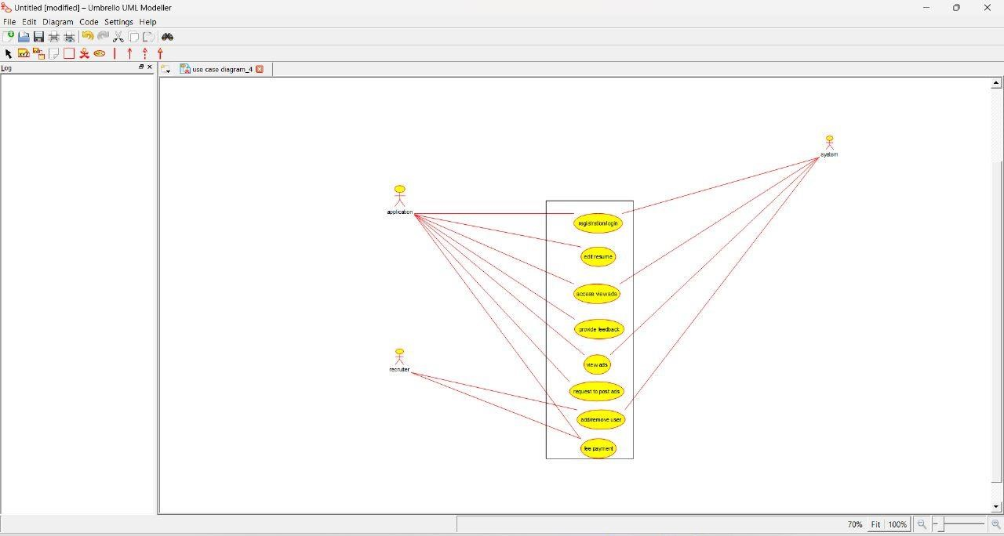

**ACTIVITY DIAGRAM:**

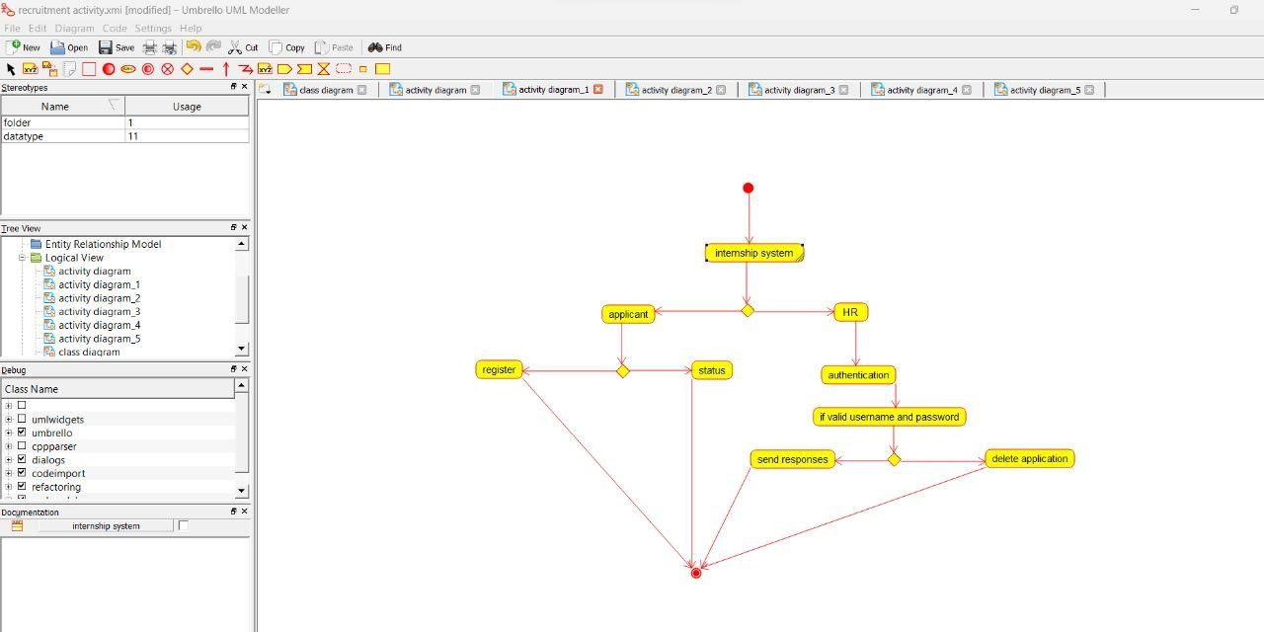

**SEQUENCE DIAGRAM:**

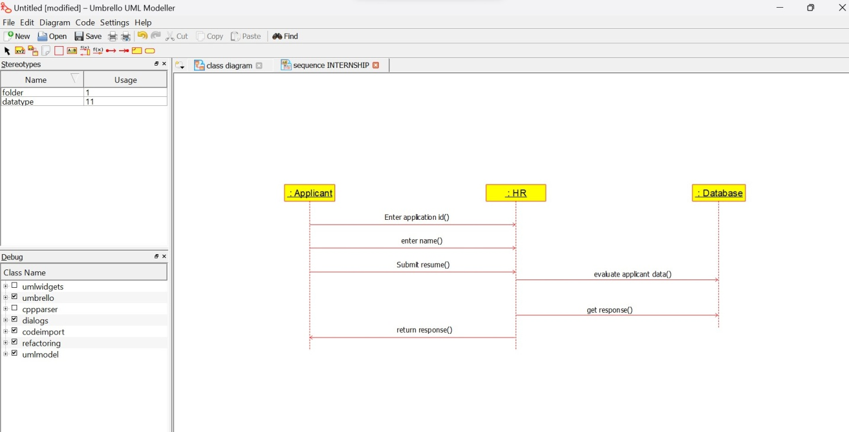

**CLASS DIAGRAM:**

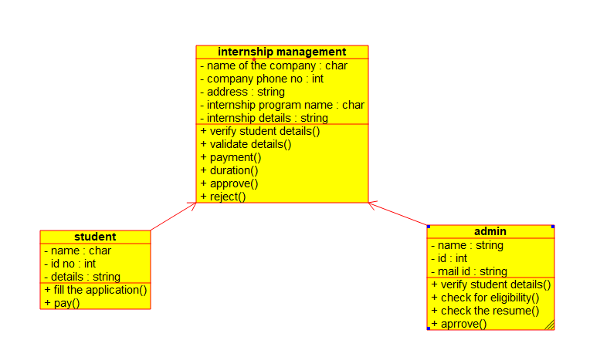

**COMPONENT DIAGRAM:**

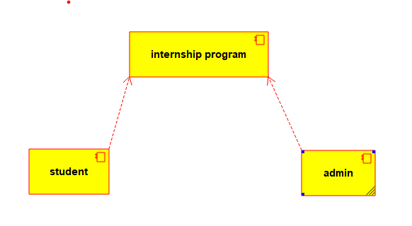

**COLLABIRATION DIAGRAM:**

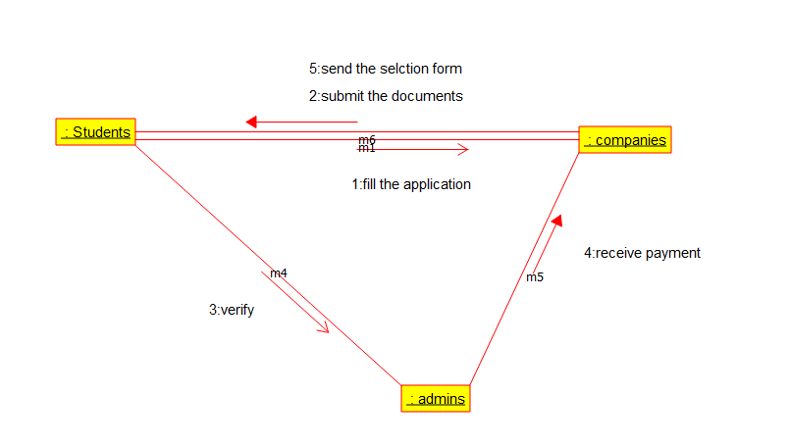

**DEPLOYMENT DIAGRAM:**

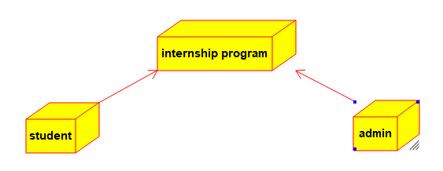

**STATE CHART DIAGRAM:**

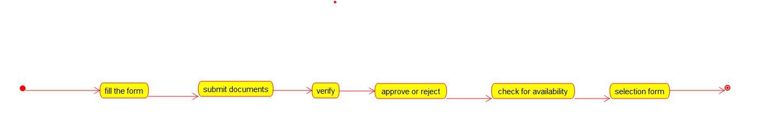

**PROGRAM:**

STUDENT:

/**

* Class admin

*/

public class admin {

//

// Fields

//

private String name;

private int id;

private String mail_id;

//

// Constructors

//

public admin () { };

//

// Methods

//

//

// Accessor methods

//

/**

* Set the value of name

* @param newVar the new value of name

*/

public void setName (String newVar) {

name = newVar;

}

/**

* Get the value of name

* @return the value of name

*/

public String getName () {

return name;

}

/**

* Set the value of id

* @param newVar the new value of id

*/

public void setId (int newVar) {

id = newVar;

}

/**

* Get the value of id

* @return the value of id

*/

public int getId () {

return id;

}

/**

* Set the value of mail_id

* @param newVar the new value of mail_id

*/

public void setMail_id (String newVar) {

mail_id = newVar;

}

/**

* Get the value of mail_id

* @return the value of mail_id

*/

public String getMail_id () {

return mail_id;

}

//

// Other methods

//

/**

*/

public void verify_student_details()

{

}

/**

*/

public void check_for_eligibility()

{

}

/**

*/

public void check_the_resume()

{

}

/**

*/

public void aprrove()

{

}

}

/**

* Class student

*/

public class student {

//

// Fields

//

private char name;

private int id_no;

private String details;

//

// Constructors

//

public student () { };

//

// Methods

//

//

// Accessor methods

//

/**

* Set the value of name

* @param newVar the new value of name

*/

public void setName (char newVar) {

name = newVar;

}

/**

* Get the value of name

* @return the value of name

*/

public char getName () {

return name;

}

/**

* Set the value of id_no

* @param newVar the new value of id_no

*/

public void setId_no (int newVar) {

id_no = newVar;

}

/**

* Get the value of id_no

* @return the value of id_no

*/

public int getId_no () {

return id_no;

}

/**

* Set the value of details

* @param newVar the new value of details

*/

public void setDetails (String newVar) {

details = newVar;

}

/**

* Get the value of details

* @return the value of details

*/

public String getDetails () {

return details;

}

//

// Other methods

//

/**

*/

public void fill_the_application()

{

}

/**

*/

public void pay()

{

}

}

ADMIN:

/**

* Class admin

*/

public class admin {

//

// Fields

//

private String name;

private int id;

private String mail_id;

//

// Constructors

//

public admin () { };

//

// Methods

//

//

// Accessor methods

//

/**

* Set the value of name

* @param newVar the new value of name

*/

public void setName (String newVar) {

name = newVar;

}

/**

* Get the value of name

* @return the value of name

*/

public String getName () {

return name;

}

/**

* Set the value of id

* @param newVar the new value of id

*/

public void setId (int newVar) {

id = newVar;

}

/**

* Get the value of id

* @return the value of id

*/

public int getId () {

return id;

}

/**

* Set the value of mail_id

* @param newVar the new value of mail_id

*/

public void setMail_id (String newVar) {

mail_id = newVar;

}

/**

* Get the value of mail_id

* @return the value of mail_id

*/

public String getMail_id () {

return mail_id;

}

//

// Other methods

//

/**

*/

public void verify_student_details()

{

}

/**

*/

public void check_for_eligibility()

{

}

/**

*/

public void check_the_resume()

{

}

/**

*/

public void aprrove()

{

}

}